GROUP TWO(2)
Group Members:
Business Website for West bridge system(WBS)

ICT233; Web Technologies and Design

^{ITE 2H}
GROUP TWO(2)
NAMES | INDEX NUMBER
SURAJ BAYARI TOFIC | 5230100711
RANDY STANLEY FORDJOUR WIREDU | 5230100712
PORTIA DUFIE ANTWI | 5230100713
OPOKU KINGSLEY JUNIOR | 5230100714
ELVIS OFORI | 5230100715
SAMUEL ASARE FRIMPONG | 5230100716
YAW OWUSU FORKUO | 5230100717
KELVIN BOAKYE BOADU | 5230100718
SAMUEL ASIAMAH SARPONG | 5230100719
OSEI MICHAEL POKU | 5230100720

Project Background
Project Title: West Bridge System (WBS)
Background: West Bridge System (WBS) is a company dedicated to delivering innovative digital solutions such as computer repairs, GPS tracker installations, camera installations, network setup, and web development.
Need for Website: A website is essential to showcase WBS's services, reach more clients, and provide an accessible platform for customers to explore offerings and get in touch. It enhances professional presence, improves communication, and supports business growth.
West Bridge System (WBS) is a growing technology solutions provider based in Tumu, Upper West Region, Ghana. The company offers a wide range of technical services, including GPS tracker installation, camera surveillance setup, computer maintenance and repair, professional web development, and network installation services.
In an increasingly digital world, having a strong online presence is crucial for business visibility, customer trust, and service accessibility. The website project was initiated to provide a centralized and accessible platform where clients can learn about WBS services, view visuals of past work, and easily get in touch with the team. It aims to bridge the gap between technology service providers and clients, especially in regions where digital transformation is just gaining momentum.
The website will serve the following core purposes:
- Inform visitors about the full scope of services WBS offers.
- Showcase successful project examples through images and descriptions.
- Enable communication via integrated contact details and call-to-action buttons.
- Support growth by improving visibility and making services accessible beyond the local region.
With mobile responsiveness, clear navigation, and an emphasis on usability, the WBS website is designed to function effectively across devices and platforms. The visual design aligns with the company's identity, while features like search, navigation, and mapped location provide functionality that benefits both local and remote users.

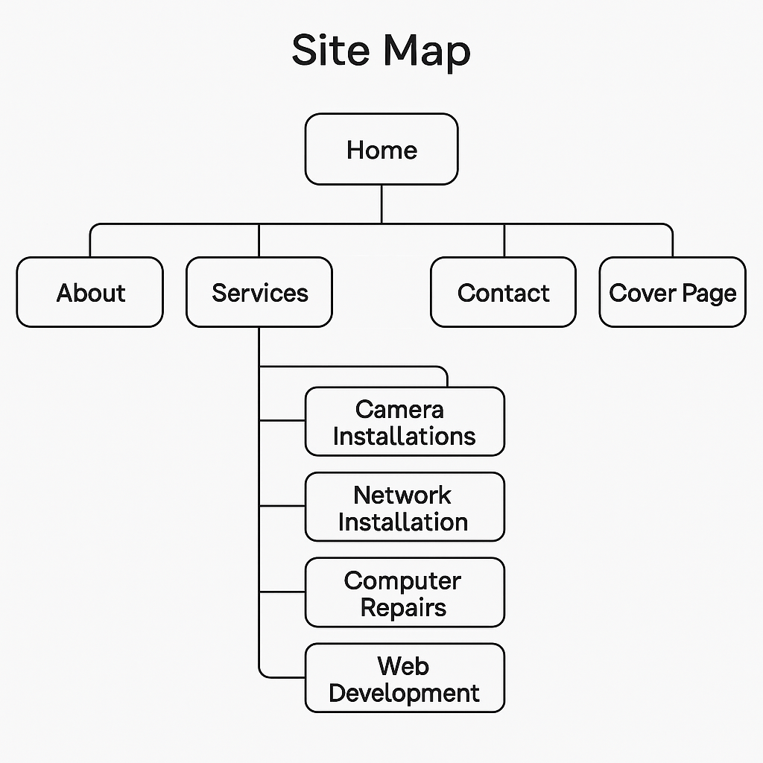
WIREFRAME
